**Example Two: Book Genre Exploration**

Youtube: <https://www.youtube.com/watch?v=XP4-FOvlxVs&t=288s>

In this video, you saw how the machine learning process can be applied to an unsupervised machine learning task that uses book description text to identify different micro-genres.

**Step One: Define the Problem**

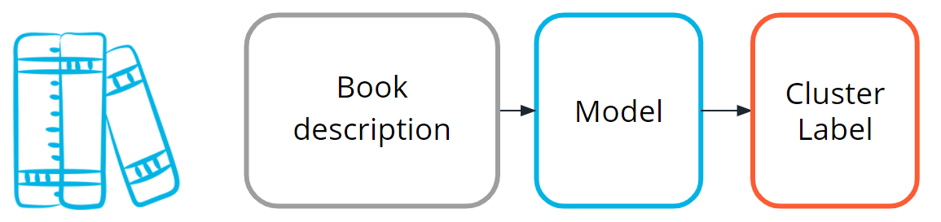

Model used to predict micro-genres

Find clusters of similar books based on the presence of common words in the book descriptions.

You do editorial work for a book recommendation company, and you want to write an article on the largest book trends of the year. You believe that a trend called "micro-genres" exists, and you have confidence that you can use the book description text to identify these micro-genres.

By using an unsupervised machine learning technique called *clustering*, you can test your hypothesis that the book description text can be used to identify these "hidden" micro-genres.

Earlier in this lesson, you were introduced to the idea of unsupervised learning. This machine learning task is especially useful when your data is not labeled.

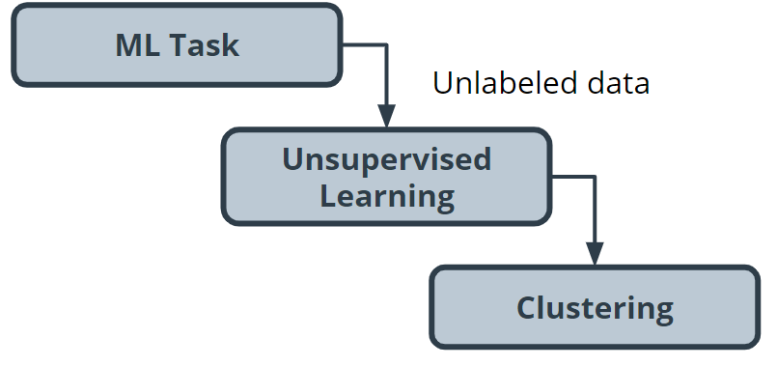

Unsupervised learning using clustering

**Step Two: Build your Dataset**

To test the hypothesis, you gather book description text for 800 romance books published in the current year.

**Data exploration, cleaning and preprocessing**

For this project, you believe capitalization and verb tense will not matter, and therefore you remove capitals and convert all verbs to the same tense using a Python library built for processing human language. You also remove punctuation and words you don’t think have useful meaning, like '*a'* and '*the'*. The machine learning community refers to these words as *stop words*.

Before you can train the model, you need to do some data preprocessing, called *data vectorization*, to convert text into numbers.

You transform this book description text into what is called a bag of wordsrepresentation shown in the following image so that it is understandable by machine learning models.

How thebag of words representation works is beyond the scope of this course. If you are interested in learning more, see the **Additional Reading** section at the bottom of the page.

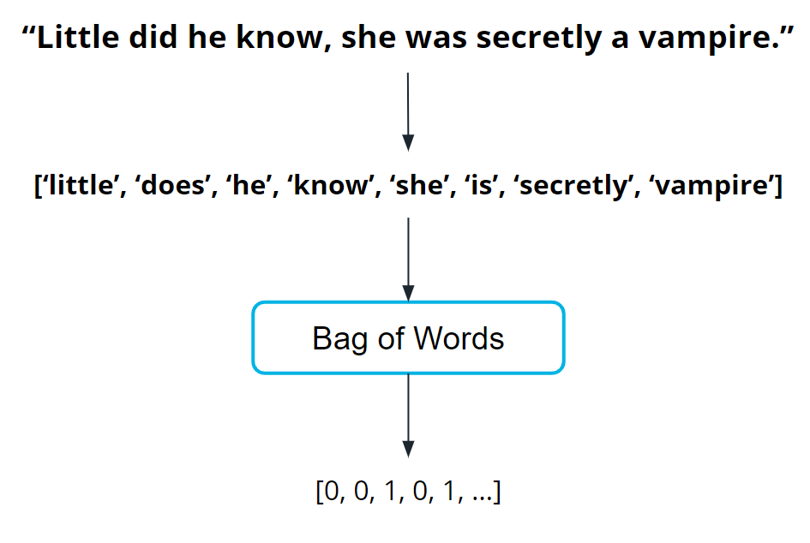

**Step Three: Train the Model**

Now you are ready to train your model.

You pick a common cluster-finding model called k-means. In this model, you can change a model parameter, k, to be equal to how many clusters the model will try to find in your dataset.

Your data is unlabeled: you don't how many microgenres might exist. So you train your model multiple times using different values for k each time.

What does this even mean? In the following graphs, you can see examples of when k=2 and when k=3.

|  |  |
| --- | --- |
| kmeans k=2 K=2 | kmeans k=3 K=3 |

During the model evaluation phase, you plan on using a metric to find which value for **k** is most appropriate.

**Step Four: Model Evaluation**

In machine learning, numerous statistical metrics or methods are available to evaluate a model. In this use case, the *silhouette coefficient* is a good choice. This metric describes how well your data was clustered by the model. To find the optimal number of clusters, you plot the silhouette coefficient as shown in the following image below. You find the optimal value is when k=19.

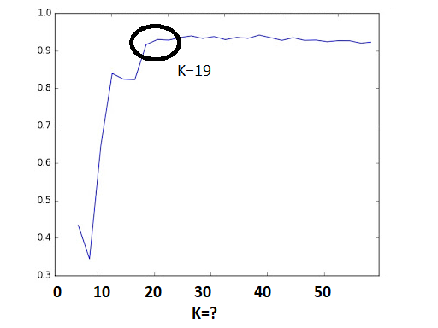

Optimum number (k=19) of clusters

Often, machine learning practitioners do a manual evaluation of the model's findings.

You find one cluster that contains a large collection of books you can categorize as “paranormal teen romance.” This trend is known in your industry, and therefore you feel somewhat confident in your machine learning approach. You don’t know if every cluster is going to be as cohesive as this, but you decide to use this model to see if you can find anything interesting about which to write an article.

**Step Five: Inference (Use the Model)**

As you inspect the different clusters found when k=19, you find a surprisingly large cluster of books. Here's an example from fictionalized cluster #7.

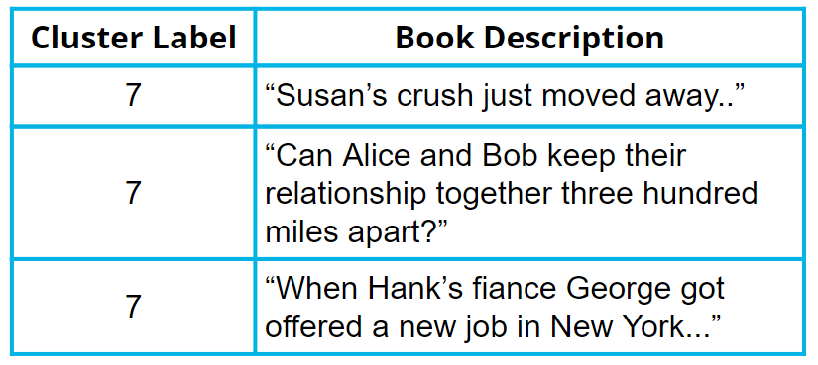

Clustered data

As you inspect the preceding table, you can see that most of these text snippets are indicating that the characters are in some kind of long-distance relationship. You see a few other self-consistent clusters and feel you now have enough useful data to begin writing an article on unexpected modern romance microgenres.

**Terminology**

* **Bag of words**: A technique used to extract features from the text. It counts how many times a word appears in a document (corpus), and then transforms that information into a dataset.
* **Data vectorization**: A process that converts non-numeric data into a numerical format so that it can be used by a machine learning model.
* **Silhouette coefficient**: A score from -1 to 1 describing the clusters found during modeling. A score near zero indicates overlapping clusters, and scores less than zero indicate data points assigned to incorrect clusters. A score approaching 1 indicates successful identification of discrete non-overlapping clusters.
* **Stop words**: A list of words removed by natural language processing tools when building your dataset. There is no single universal list of stop words used by all-natural language processing tools.

**Additional reading**

[Machine Learning Mastery](https://machinelearningmastery.com/) is a great resource for finding examples of machine learning projects.

* The [How to Develop a Deep Learning Bag-of-Words Model for Sentiment Analysis (Text Classification)](https://machinelearningmastery.com/deep-learning-bag-of-words-model-sentiment-analysis/) blog post provides an example using a bag of words–based approach pair with a deep learning model.